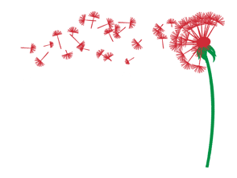

Italian Diaspora Studies
Writing Retreat 2023

Application Form

Thank you for your interest in the Italian Diaspora Studies Writing Retreat 2023. To finalize enrollment, please respond to our questionnaire.

Name

Address

Cell Phone

Email address

- Do you have particular needs, allergies, dietary, or other? Please explain.

- Are you participating alone or with one or more companions?

- Supplement for single room: YES or NO

- Are you interested in attending classes of Conversational Italian? If so, how would you define your proficiency in Italian?

We will confirm your participation in the program by December 2022. As we can only accept a limited number of participants, please respect the following payment deadlines in order to be guaranteed a place.

Cost of the program
EUR 3000 (extra supplement for single room EUR 500)

Dates: May 12-22, 2023.
May 12 Arrival — May 22 Departure.

The price includes: 1) Attendance of workshops and other cultural activities offered by the program. 2) Transportation from the airport of Lamezia Terme to the locations of the program and back, or to the railway station of Paola (CS) and back, on the arrival and departure dates. It does not include transportation from different airports or railway stations and transportation in different dates. 3) Accommodations in double rooms with private bathrooms (unless the reservation for a single room is chosen). 4) Breakfast and two meals a day every day.

Payment of the first instalment of EUR 1500 must be made by January 15th; the second instalment by February 15th. It is possible to pay the entire amount by the first deadline.

In case of cancellation, we will provide a partial refund of 50% of the paid amount if the cancellation is done before March 30, 2023. After this deadline, no refunds will be made.

Please Note: Payments are due trough international wire transfers. Our bank details will be emailed to you with a letter of acceptance at the beginning of December 2022.

Signature (if you can’t attach your signature, your email to us will work as a signature)

Date

Kind Regards.

Prof. Margherita Ganeri
italiandiasporastudies@gmail.com

